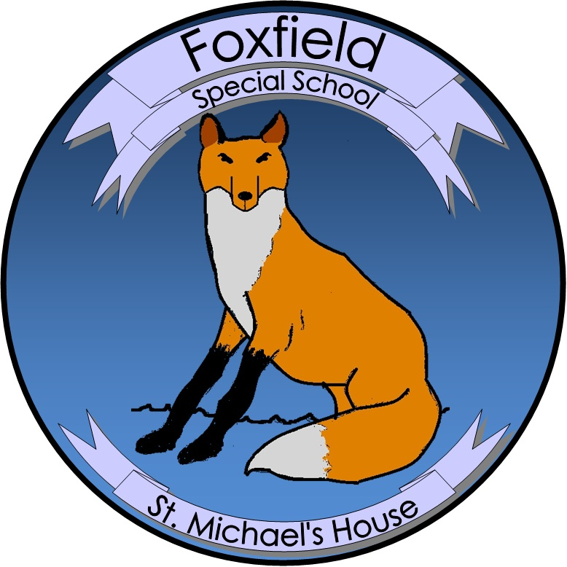

**St. Michael’s House Special School Foxfield**

Agreed report, BOM Meeting 15 October 2024

* The Admissions Policy and Admissions Notice are now on the website and applications for 2025-2026 are now being accepted
* The Child Safety Statement for 2024-25 has been ratified and is now available on the website
* The Health and Safety policies for both campuses were reviewed and ratified
* All staff will participate in a Training Day on 18 October. The teachers will receive training in the L1LP curriculum. There are two courses being held for SNAs in First Aid and in Epilepsy.
* The General Purpose hall in Swords should be completed in the next few weeks