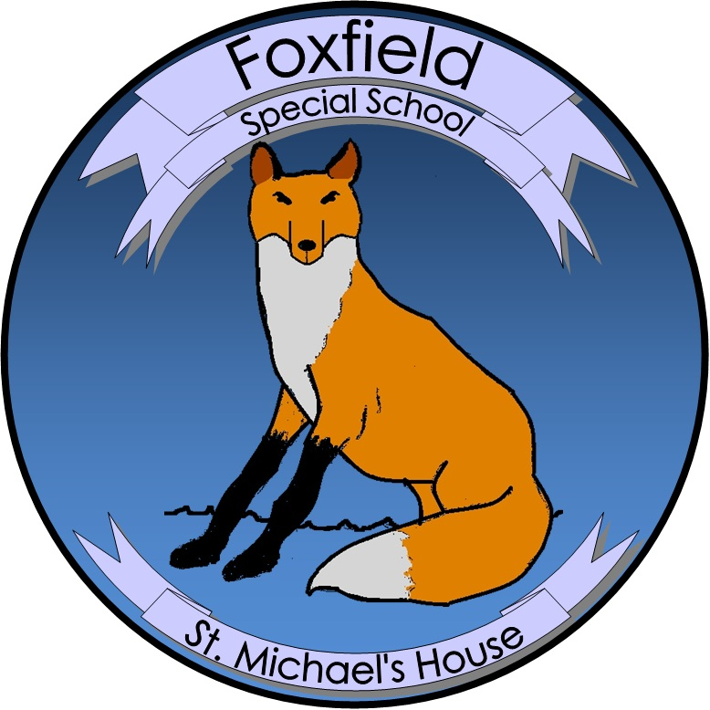

**St. Michael’s House Special School Foxfield**

**Agreed Report Board of Management Meeting 19.09.24**

* During the summer a good deal of work took place on both campuses. In Kilbarrack, pavements were repaired, a mural was painted in a corridor and a school sign was installed. In Swords, fences were made higher and safer and a new gate was installed.
* Kilbarrack and Swords campuses now have the same SENO, Erin Murphy and the same NCSE Team Leader, Mark Reddy.
* The Board thanked Colin Clarke for his years serving as treasurer of the BOM. Colin is remaining on the Board but has handed the role of treasurer over to Barry Kavanagh.
* Four new pupils started the new school year in Kilbarrack, one new pupil has joined the school in Swords. They are all settling in well and we are happy to welcome all of them to the Foxfield family.
* Work will begin in the coming weeks to install a General Purpose hall in Swords. This will provide indoor play space which is essential with winter approaching.
* Teacher interviews were held in August. We are delighted that as a result of interviews, Niamh O’Curry has joined our team in Kilbarrack.
* **Date of Next Meeting: 15 October, 2024**